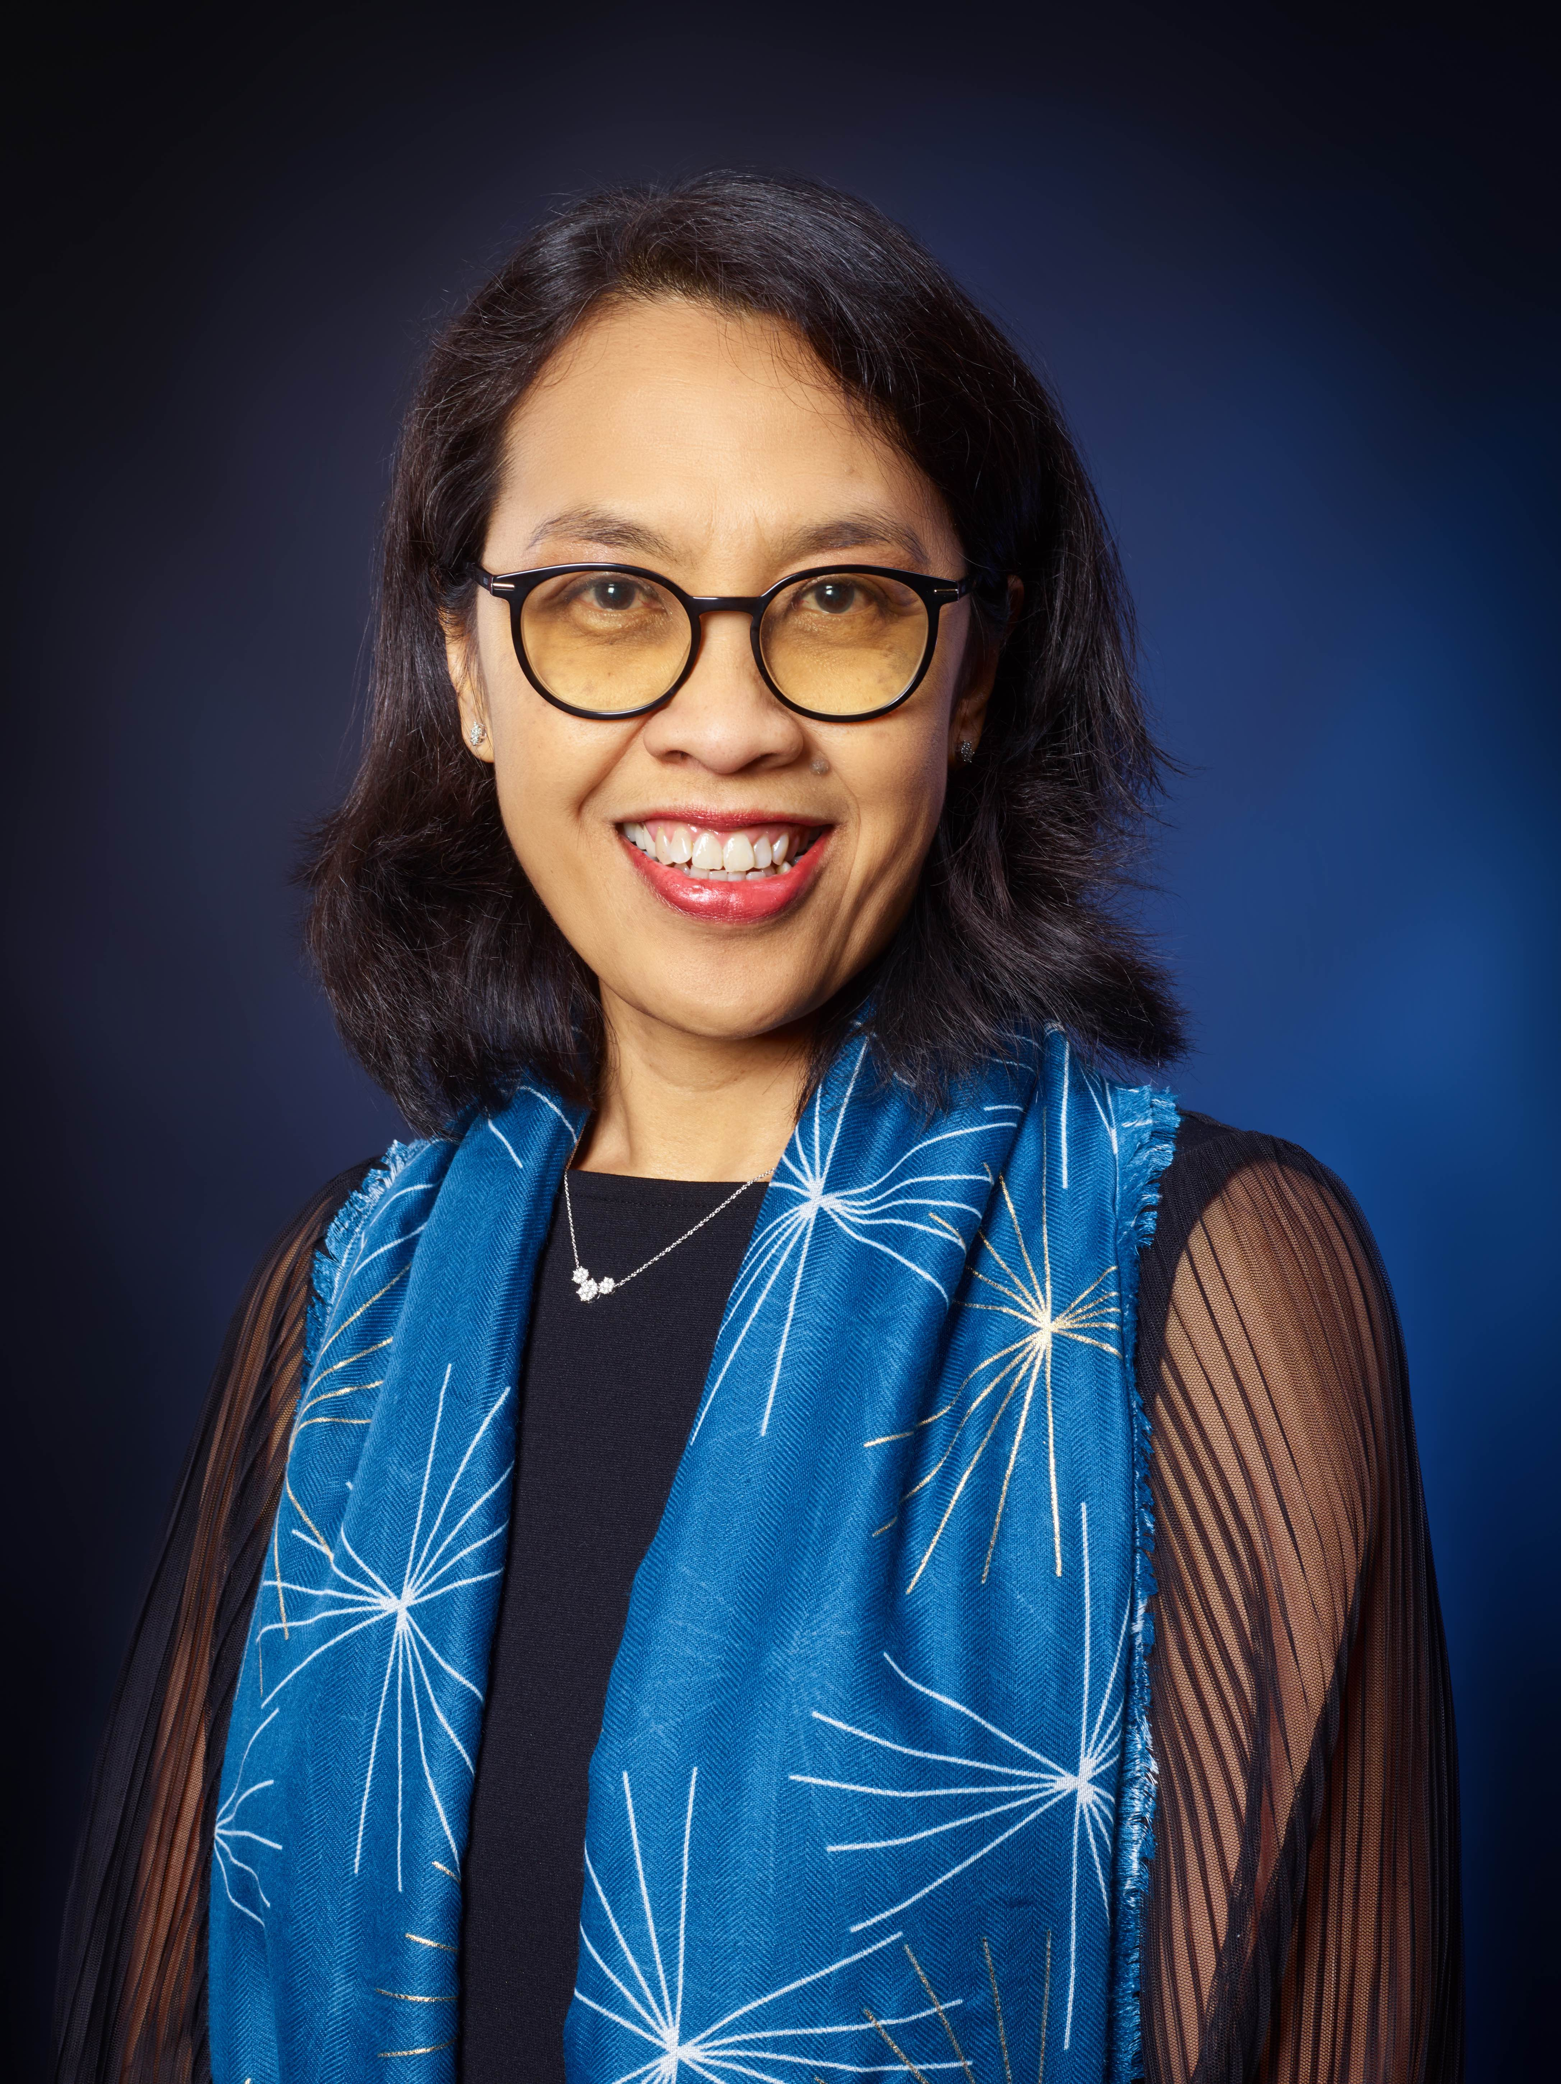

**Ms. Ariesta Ningrum, Director, UN Climate Technology Centre and Network, Climate Change Division**

Ms. Ariesta Ningrum has over twenty years of professional experience in the fields of climate change, environment and energy, of which the last fifteen years with the UNFCCC Climate Change secretariat in Bonn, Germany.

Graduated as a chemical engineer, her career includes working with an Indonesian government agency in assessing and applying technologies, a non-profit organization advising the development of renewable energy potential, and a consulting firm developing a portfolio of the Kyoto Protocol's Clean Development Mechanism projects.

Most recently, Ariesta worked as the Manager of Technology subdivision at the UNFCCC, leading the Technology Executive Committee team to support intergovernmental process on climate technology development and transfer and the implementation of climate technology action under Paris Agreement, and spearheading collaboration and partnerships on technology with wider climate stakeholders.