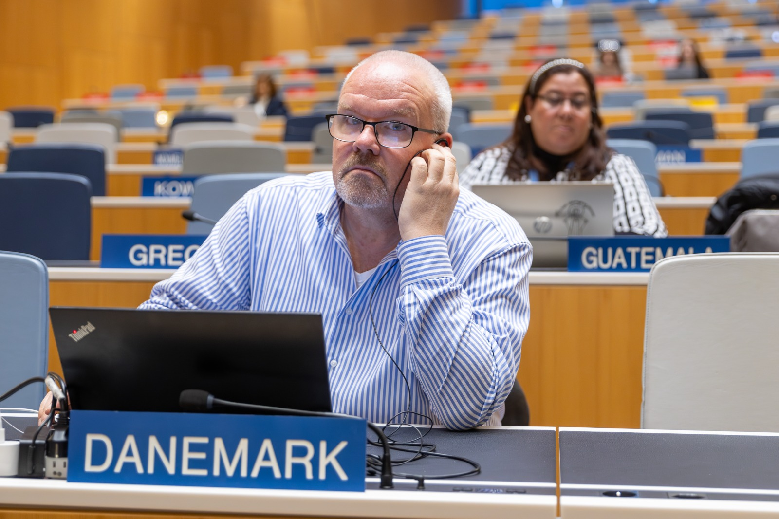

**Mr. Michael Poulsen, Head of Department International Projects, Danish Patent and Trademark Office**

Michael Poulsen has 20+ years of experience from the Danish Patent and Trademark Office. He has exclusively worked within international affairs at the Danish office and has since 2016 been managing the division for donor funded government - to - government cooperation projects which presently entails initiatives in India, Brazil, Colombia, South Africa and Indonesia.

Earlier in his carrier he has been deployed by the Danish office to the IP offices in respectively Poland, Croatia and Serbia, where he has spent at total of 5,5 years in functions supporting the respective countries preparing themselves for future EU membership.