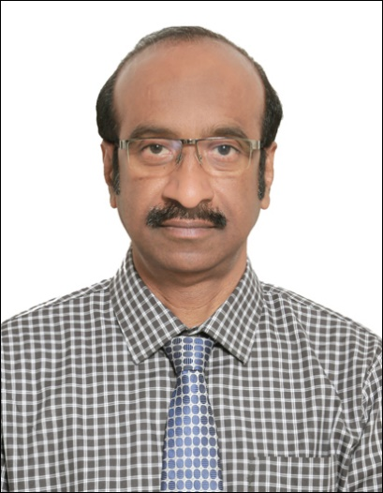**Ms. Nagrur Govindappa Lakshminarayan,** **Deputy General Manager for Business Development , NRDC**

**Mr. Nagrur Govindappa Lakshminarayan** is Deputy General Manager for Business Development at the National Research Development Corporation (NRDC) in India. With nearly three decades of experience, he has led the acquisition, protection, and commercialization of innovations across sectors such as agriculture, biotechnology, pharmaceuticals, food, and sericulture. He has concluded more than 250 technology transfer agreements and has been instrumental in advancing programmes that support start-ups and small enterprises in bringing new technologies to market.

He holds an M.Tech. in Biotechnology and Engineering from the Indian Institute of Technology, Kharagpur, as well as an M.Sc. and B.Sc. in Agricultural Microbiology from the University of Agricultural Sciences, Bengaluru. Throughout his career, he has collaborated widely with R&D institutions, universities, NGOs, and industry, and has overseen national innovation initiatives including conferences, training centres, and intellectual property facilitation programmes.