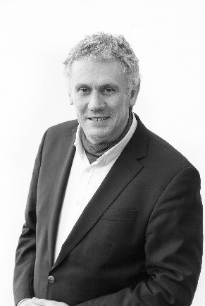 |  | Bruno Vandermeulen  IP Disputes & Transactions Specialist  Advocaat, Avocat, Lawyer  Avenue Louise 65 b. 11  1050 Brussels (Belgium)  Mobile : +32-479.500.303  bruno.vandermeulen@outlook.com  Skype : bruno.vandermeulen

Bruno Vandermeulen is a Belgian lawyer practising in Brussels since 1990 in the field of intellectual property litigation and technology transfer with working experience at major law firms in the US and Belgium (Pennie & Edmonds in New York City, Loeff Claeys Verbeke and Bird & Bird in Brussels). After an education in the arts of film and television at the “Institut des Arts de Diffusion” in Louvain-La-Neuve (1983) he graduated from the law faculty of the KULeuven in 1988 and obtained a Master in Laws (LL.M) at the University of Georgia (USA) in 1989. He became an expert in IP litigation as founder and of the Belgian IP department of Bird & Bird during twenty years (1999-2018) and won several awards in the field of international patent litigation. He is also an active member of the Licensing Executives Society International (LESI) where he was Board member and President of its Benelux Chapter, Chair of the LESI European Committee and Counsel to the LESI Board.

Bruno is since 2004 a member of the editorial board of the Belgian IP journal “Intellectuele Rechten – Droits Intellectuels” (IRDI) and chaired that Board from 2008 to 2018. He publishes about various issues in intellectual property litigation and technology transfer.

Bruno is since 2009 an expert member of Belgium’s Council for Intellectual Property, a WIPO “List of Neutrals” Arbitrator since 2019, and Vice-Chair of the Disciplinary Commission of the Belgian Patent Attorney Institute since 2021. He is accredited since 2009 as a teacher in technology transfer with the European Patent Office (EPO) and with the Licensing Executive Society (LESI).

Since 2019, Bruno is working as an independent IP lawyer and teaches intellectual property law via a blended online course produced under his guidance by the Paul Janssen Futurelab at the University of Leiden (The Netherlands). He is also a non-executive director at the Belgian non-profit organisation “Impact Licensing Initiative” where he assists companies and knowledge institutions in licensing their intellectual property for societal purposes according to the United Nations’ Sustainable Development Goals (SDG’s).

°
° °

